|  |
| --- |
|  |
|  |

|  |  |  |  |  |  |
| --- | --- | --- | --- | --- | --- |
| REVISION HISTORY | | | | | |
| Ver. | Description of Change | Author | Date | Approved | |
| Name | Effective Date |
| 1.0 | Initial status | [Kiryl Bucha](mailto:Kiryl_Bucha@epam.com) | 12-JAN-2012 |  |  |
| 2.0 | Updated in accordance with renewed content | [Elias Nema](mailto:Elias_Nema@epam.com) | 20-JAN-2014 |  |  |

Contents

1. Hands-On Task 3

2. Data Modeling Task 3

3. Analytical task 3

3.1. Partitioning 3

3.2. Business 3

4. Results 3

# Hands-On Task

Create any table with some kind of partitioning to show next concepts:

**SQL-script for creating table:**

CREATE TABLE part_table

( key_column NUMBER NOT NULL,

name_c varchar2(20),

birth_date date

)

PARTITION BY RANGE (birth_date)

(

PARTITION part_1 VALUES LESS THAN (to_date('01.01.2007','DD.MM.YYYY')),

PARTITION part_3 VALUES LESS THAN (to_date('01.01.2009','DD.MM.YYYY')),

PARTITION part_4 VALUES LESS THAN ( MAXVALUE )

);

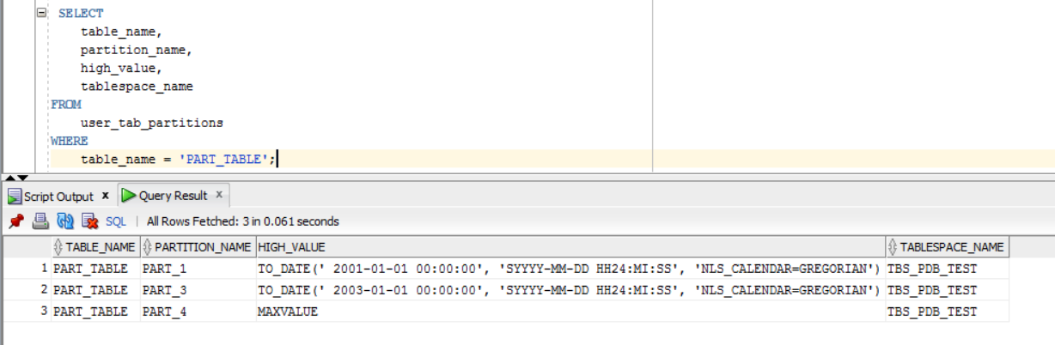

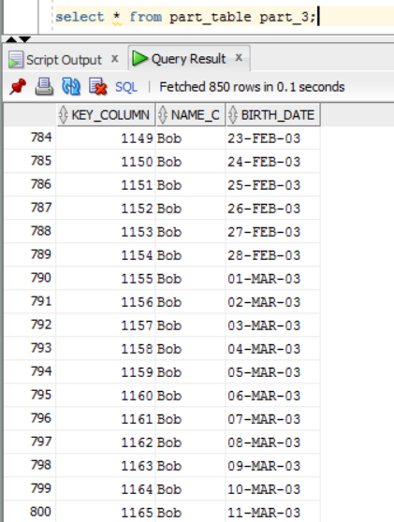

* Adding Partition

The screenshot below demonstrate, that I have an error while adding new partitions because there is a partition with values less than maxvalue.

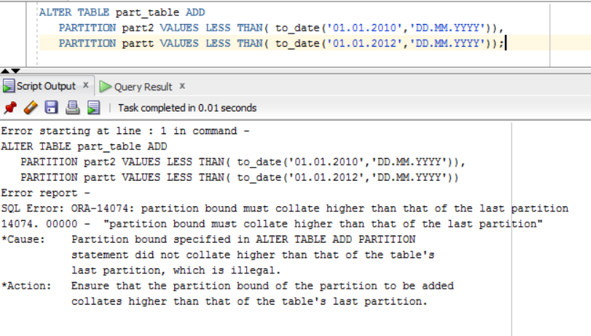

* Dropping Partition.

To drop partition alter table *table_name* drop partition *partition_name* is used:

alter table part_table drop partition part_4;

Now the partition with values less than maxvalue has been dropped.

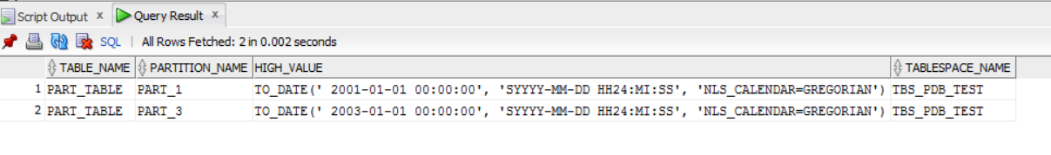

After that new partitions have been added.

ALTER TABLE part_table ADD

PARTITION part2 VALUES LESS THAN( to_date('01.01.2010','DD.MM.YYYY')),

PARTITION partt VALUES LESS THAN( to_date('01.01.2012','DD.MM.YYYY'));

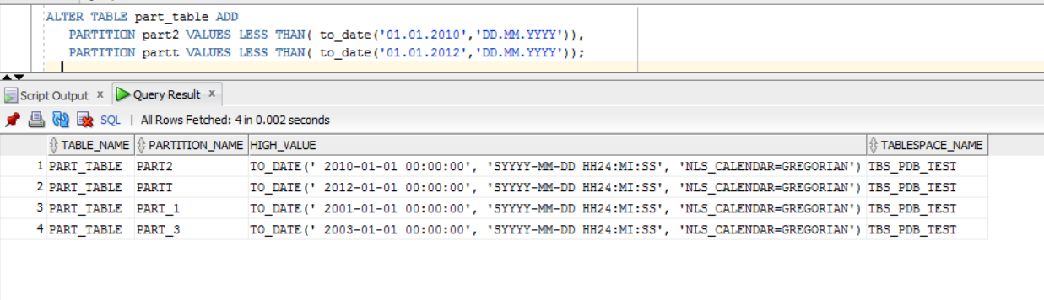

* Merging Partition.
* Moving Partition.
* Splitting Partition.
* Truncating Partition
* Coalescing Partition.

# Analytical task

## Partitioning

Add chapter on describing Fact table partitioning strategy, which fields will it be based on and why (use composite partitioning).

## Business

Create a report layout of the task you are trying to solve with your DWH (e.g. 'I want to analyze my sales on month and customers' region location and product type'). It could be done in Excel (just some headers, colors, dummy numbers, and little description) or any other tool of your preference. This would help to understand what task we are trying to solve.

# Results

Result of this lab work should be:

* Screenshots and description of partitioning maintenance operations.
* Chapter in document about advantages of partitioning the fact table in described way.
* Chapter in a document describing needed reports with possible layouts.